Financial GPS Notes

Sidebar lists app, data quality, fire benefits, etc (see screenshot below) but you need to be on “app” to actually use the application. Are these visible by mistake?

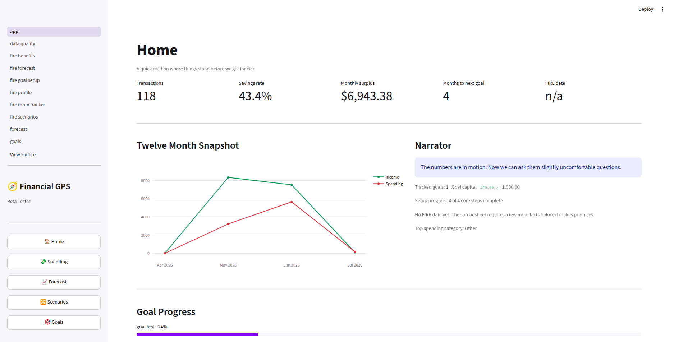

Spending
- Can expenses be offset by another transaction? For example, if banking fees are $5 then a rebate is deposited and coded to the same category – will it reduce the expense? The same would apply to other types of transactions – if user paid for something then received etransfers to be paid back; can these etransfers reduce the expense?

Forecast
- Conservative and optimistic return 0 – might not have things configured correctly.
- Expected just returns negative like you will be broke.
- Should incorporate more variables – seems very basic forecast

Scenarios
- Same as above
- Creating scenarios should be more in depth by incorporating the apps existing scenarios together.
  - For example: A scenario can include buying a house and new job.
    - I don’t like in the scenarios builder that in the example of creating a new job; the commute cost change is a set field. The fields should be fully customizable based on your spending categories.
    - The user should be able to add these types of fields themselves

** Reference ProjectionLab for this area of the application.
Goals
- I don’t really know how goals work; my vision with these is that they’d be able to update themselves based on your imported transactions but if you do not save enough it should be detected.
  - Example: If user wanted to create $5000 vacation goal; how will they know what they have leftover that can be allocated towards this goal.
- Similar to a goal; should be a feature for gifts/birthday money buckets.
  - User receives $500 in gifts then spends $250 – shouldn’t go against their expenses as it was a gift.

FIRE Planner - Financial Profile
- Onboarding Wizard should help to set this up
- DOB selection doesn’t let you select a day you were born; only lets you pick the 1st. Not sure if this matters
- Employment income seems to calculate off of whats imported into the bank transactions; however this would be after tax. Need to consider what would be better for forecasting – should user record their gross income? How do we factor taxes? How do other tools consider this?
- Years in canada after 18 box is confusing; same with Canadian resident. If you are a resident then does this even need to be a box?

FIRE Planner - Account Room Tracker
- Unsure if tracking the account room is a priority but would be nice down the road – need to research if there would be an easy way to import this information from either CRA or users bank csv.
- Might be helpful to reference ProjectionLab again – they allow you to setup the different accounts

Benefits Workspace
- Unsure how this is useful/if it should be it’s own section. Definitely useful for forecasting but maybe this would be a section within? Just a thought not a hard change.

Fire Goal Setup
- Need the different fire variants explained. User may not know the difference or what is best for them.
FIRE Forecast
- Consolidate with the other forecast menu? They are ultimately providing the same thing.

Fire Scenarios
- Same thing mentioned above but consolidated with the scenarios menu
Data Quality
- Good – should be minimal concerns after user completes setup wizard

Settings
- Should be more organized into different sections after clicking onto the settings page.
  - Profile settings broken out, categorization rules, categories, etc.

Misc notes:
- Programs to reference: MonarchMoney, YNAB, ProjectionLab
  - Should bank accounts reconcile/show account balance to tie to source?

